Bibliography

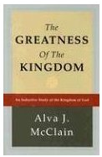

**The Greatness Of The Kingdom,** Alva McLain, BMH Books (reprint) 2001

**Daniel, the Key to Prophetic Revelation,** John Walvoord,

Moody Press, , 1971, 1989

*Also* Kindle Edition

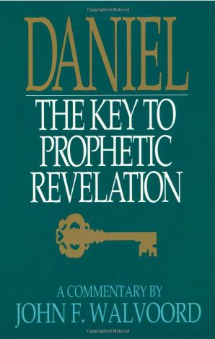

**The Revelation of Jesus Christ,** John Walvoord,

Moody Press, , 1966, 2011

*Also* Kindle Edition



**The Coming Prince,** Sir Robert Anderson,

Cosimo Classics, 2007

Kregel Reprint, 1957

Kindle Edition



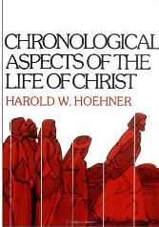

**Chronological Aspects of the Life of Christ**, Harold Hoehner

Zondervan, 1978

**The Chronological Gospel Commentary**, Michael Hagerty

Primrose Lane Publishing, 2011

