Daniel Chapter 9 – Prophecy of the Seventy Weeks

Outline

The Divine Purposes of the Prophecy

**to finish the transgression**

**to make an end of sin**

**to make atonement for iniquity**

**to bring in everlasting righteousness**

**to seal up vision and prophecy**

**to anoint the most holy**

The Period of the Prophecy

**The sixty-nine weeks as seven and sixty-two**

**The seventieth week**

Weeks of What? - ***Literal vs. symbolic***

Predicted Events of the Prophecy

**Jerusalem rebuilt**

**Messiah comes and is cut off**

**Jerusalem and Temple destroyed**

**The prince who shall come**

**The seven-year covenant**

**Breaking the covenant mid-week**

**Abomination of Desolation**

**The Desolator destroyed**

The Prince Who Shall Come

**as Messiah?**

**as the Roman General Titus?**

**as a future prince?**

Daniel’s Prophecy of The Seventy Weeks

**Our Objectives**

**The Divine Purposes of the Prophecy**

**The Period of the Prophecy**

**The Predicted Events of the Prophecy**

**Divine Purposes in the Prophecy**

The prophecy discloses its objectives – the things to be achieved by the period of the weeks:

* **to finish the transgression**
* **to make and end of sin**
* **to make atonement for iniquity**
* **to bring in everlasting righteousness**
* **to seal up vision and prophecy**
* **to anoint the most holy [place]**

As we review these phrases, we can see some application to the time of the Jews of Daniel’s timeframe and that of Nehemiah in their return. This is made for clear by the use of the definite article *“the”* as in *the transgression*, meaning something known to the hearers.

The phrase *“the transgression”* uses the definite article in Hebrew (*he -* (hey) - prefixed to the word for transgression). This indicates a specific transgression known to the hearers.

As for a specific transgression to be *finished*, the sin was that of idolatry, which Judah never committed again as a nation in all its future history.

*“to make an end of sin”* is without the article, which technically means a sin. Since the author has gone to the trouble to mention *the transgression* as something well-known, it would be odd to follow this with *a sin.* For this reason the condition of no article means the generic sense of sin in general. Not *a* sin, not *the* sin, but sin as a principle alienation from God.

As such, that objective of the prophecy cannot be seen as achieved at release of the Jews from Babylon at the beginning of the period. It can only be seen as related to the accomplishments at the Cross and the sacrifice of Christ.

To make atonement for iniquity seems like a repetition, but it is an expansion of the end of sin by showing us the means – an atonement which has been waiting through the centuries of sacrifices for the *fullness of time*.

*“to bring in everlasting righteousness”* is obviously something not achieved historically in the Jews of Daniel’s time. Some may offer that it didn’t arrive after the effects of the Cross either, since righteousness seems to be overturned for evil in the struggle we have with Satan and the carnal nature.

To be sure, the possibility of an everlasting righteousness was made possible at the Cross, and we see its fulfillment in the events of end times when Christ establishes the Kingdom and the resolution of all things in His judgment of human history.

*“to seal up vision and prophecy”* is seen by some as meaning *this* vision of the Seventy Weeks, i.e., to complete this prophecy to its end. Others see it as a securing and sealing of all prophecy from beginning to end in the resolution of all things at the coming of the Lord.

“to anoint the most holy place” brings us back to the local scene, when the work of Ezra, Nehemiah and Zerubbabel bring about a worthy and glorious restoration of divine worship at Jerusalem in the manner that pleased God.

**Breaking Down the Prophecy – Its Three Parts**

Visualizing the historical fulfillments of the first two periods of Daniel’s Seventy Weeks will help us to project how the fulfillment of the remaining and final period will play out when its time has come.

The Seventy Weeks are broken down into periods of ***seven*** and ***sixty-two***, leaving a period of ***one*** weekremaining. The *seven* and *sixty-two* follow each other consecutively in Daniel and equate to 49 years and 434 years, respectively (7x7 and 62 x 7). These two periods are also seen collectively as the first sixty-nine weeks, or 483 years.

**Period 1 Period 2 Period 3**

**70 wks**

**1**

**62**

**7**

**483 | 7 yrs**

**490 yrs**

**434 yrs**

**49 yrs**

Features that will assist us in determining the fulfillment are those of the prophecy:

* **its beginning - the date of the decree to restore and rebuild Jerusalem,**
* **the historical events that fulfill the first 49 years,**
* **our understanding of the 483 year duration period**
* **how are we to understand “unto Messiah the Prince?”**
* **its ending - the date on which the 483 years end.**

**Weeks of What?**

Many are alarmed that out of hand the weeks are said to be weeks of years without explanation, and why the literal reading of weeks must be abandoned.

It is actually a matter of eliminating interpretations that lead to nonsense or to no feasible fulfillment. And the rule of interpretation is: *“if the plain sense makes sense, seek no other.”* In this case the plain sense does not make sense, so we are obliged to look for another.

The reason the literal rendering does not make sense is that sixty-nine weeks to Messiah from the decree to restore Jerusalem doesn’t land us in any period where events fulfilled the expectation. The decree must be during the Persian period and before the return of Nehemiah, so we’re talking about the 500’s to the 450’s BC. 69 weeks is 483 days. Any decree in these years means that Messiah was expected to come a year and four months later. There simply are no events to which the coming of Messiah could be tied.

Whereas 483 years has the better likelihood because it brings us into years AD and our normal understanding of the ministry of Jesus.

We also have the precedent in Scripture of Jacob working for Laban two sets of *weeks* that turned out to be periods of seven years (Gen 29:27-28)

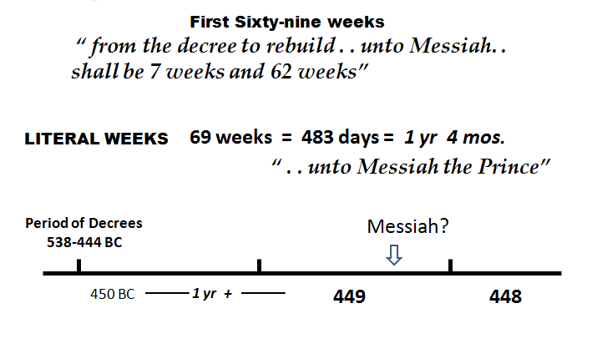

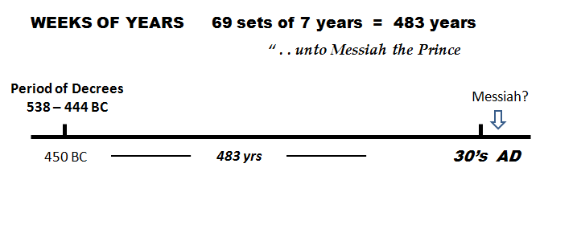

Predicted Events of the Prophecy 9:25-27

Along the way in bring about the divine purposes of the prophecy, certain events and milestones are predicted:

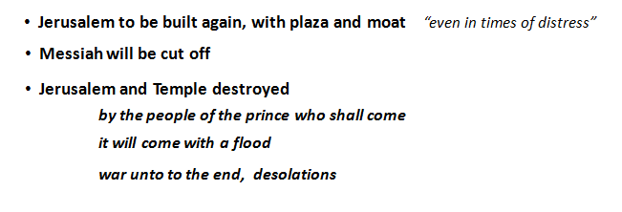

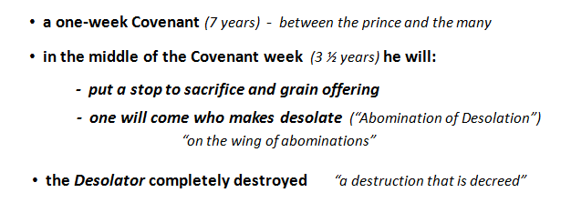

Let’s examine some key stipulations above.

*The prince who shall come* is often a prime focus in this section, and the temptation is to let it refer to the only prince thus far mentioned - the Messiah.

**Is Messiah the Prince Who Shall Come?**

We would have an immediate problem thematically. Why would Christ destroy the Temple and city? He predicts it but does not say He will be the agent.

But we must read carefully. It does not say *the prince* will destroy, but***his people*** will do it. In the case of Christ, this would mean either the Jews or Christians. Again, why would either of these people have a purpose in destroying the city and Temple?

And of course we know from history who in fact destroyed the city and Temple, neither the Jews nor Christians, but the armies of Rome.

**A Roman Prince?**

If the people destroying were the Roman people in the person of their army, then wouldn’t the prince be their general? We are then talking about the Roman general Titus, who received the conduct of the war from his father Vespasian, now emperor. The arch of Titus in Rome has commemorated this destruction for almost two millennia.

But does Titus fit as the prince who shall come? Look at the conditions Daniel assigns to this prince:

* **Titus must make a covenant of seven years**
* **Titus must break that covenant mid-point at 3 ½ years**
* **Titus must cause sacrifice and grain offering to cease**
* **Titus must commit the Abomination of Desolation**

We are without any historical events in the career of Titus that relate to any such seven-year covenant, or worse – a breach of it at 3 ½ years.

As to three and four above, some certainly see Titus causing these. Without a Temple the offerings were indeed made to cease, and the whole destruction was an abomination.

But let’s look at this more closely.

**The Abomination of Desolation**

The Abomination is of Daniel is not to be an abomination to the Jews but unto God. It is an offense in the midst of a faithful people that causes God to depart – making the Temple ‘desolate.’

In 70 AD, we have a scene of punishment of God’s people for rejecting and killing their Messiah; and in other ways they are getting their just desserts for their own instigations of rebellion against Rome.

So ironically it is precisely Israel’s God who is the prime mover in allowing this destruction, grievous as it may was. And such a destruction could not overshadow that chief abomination already done at the Cross on the part of God’s people.

As for seeing God with this attitude toward His Temple, we simply need to recall the tearing of its curtain at the death of the Savior.

Relating Titus and the one who commits this abomination, we have further cautions from Scripture:

*“and on the wing of abomination will come one who makes desolate,”*  Dan 9:27 NASB

Here we see one coming in the midst of abomination such that the Temple is made desolate – abandoned of God and all that is holy.

It is unfortunate that many translations have chosen the simpler expression, *“on the wing of abomination”* which is a valid alternative to the original words used. But we are sent off in the direction of looking for a wing in some context – a wing of the temple, an outstretched wing on some form of idol?

But the original also means,

*“and for the overspreading of abominations will come one who makes desolate,”* Dan 9:27 KJV

With this rendering, perfectly allowable, we are freed from the distraction of finding some meaningful application for *wing,* which has always ended up a stretch or in some way forced.

Enter Jesus’ commentary on this passage in Daniel. Jesus understood this to mean a specific act standing in the Holy Place. An event to be seen and therefore watched for. (Matthew 24)

Thus far, we don’t have any stipulations that would rule him out. Titus eventually came to stand in the ruins of the Holy Place *“where he ought not to be”* and for those who hold to the destruction as an abomination, Titus is still a candidate.

**Import from I & II Thessalonians**

Paul gives us the critical piece that will rule Titus out as *the prince who shall come*.

*“. . and the man of lawlessness is revealed, the son of destruction, who opposes and exalts himself above every so-called god or object of worship****, so that he takes his seat in the temple of God****, displaying himself as being God.”* (2 Thess 2:4)

In the case of Titus, has he not then just destroyed the place in which he must take his seat to display himself as God. Without a temple, Titus can do no such thing.

And of course we have no evidence that Titus did any such thing, Temple or no, while in Jerusalem.

But the key argument against this line of explanation is that Christ did not come and destroy Titus as the man of lawlessness, nor did He come again the second time as Paul describes Him in these epistles.

**A Future Prince?**

A common interpretation is that the prince who shall come is yet future, even in our own times, and is the same as the antichrist we see in The Revelation. If so, he must be seen doing the following:

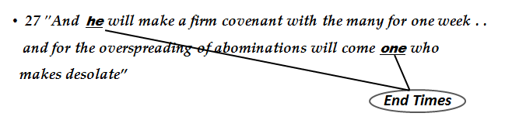

Immediately, we have the problem of how this future prince will be related to the historic destruction of Jerusalem in 70 AD? How can his people be the ancient Romans if he is considerably far into the future?

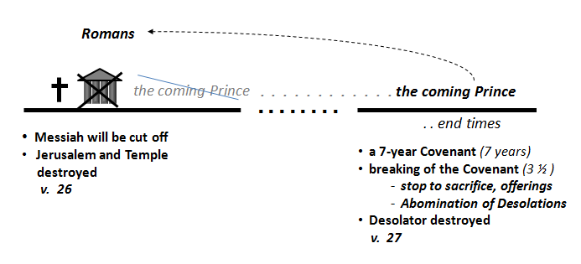

Remember from prior lessons the mysterious aspect of Rome as the fourth kingdom. In Daniel chapters two and seven we met with this concept that historic Rome was not done in human history – that there was yet a ten-fold aspect of ten kings and a little horn in relation to the fourth kingdom.

We see in end times the Little Horn and his ten kings come to complete this previously unfulfilled aspect of ancient Rome, waiting until end times for expression in the antichrist.

We can now see how a *future prince*  shall come and commit acts and an abomination in a future Temple of end times, and can also have as his people the ancient Romans, who did indeed destroy the city and sanctuary in perfect fulfillment of Daniel’s words.

He will be related to the ancient Romans in that he revives its imperial form and is later described in the Revelation as *the beast that was, was not, and now is.*

