I & II Thessalonians – The Rapture

Proof of the Rapture is not clearly stated in Scripture in near similar terms as we have for the Second Coming. Some point out the word isn’t even in Scripture. We get our concept of it from certain verses that don’t make sense, or create confusion on an assumption that there is only one coming of the Lord – the Second Coming and its resurrection.

In our study of Daniel’s seventieth week we observed that there is a formula that falls out of our conclusions about the fulfillment, that enables an observer to set the day of Christ’s return once the day of the Abomination of Desolation in Jerusalem is made known. This flies in the face of Jesus’ clear teaching that no man knows the day or hour.

Similarly, in I & II Thessalonians, certain descriptions don’t make sense on the assumption that Paul taught believers there is only one coming – the Second Coming.

We don’t see this immediately when reading the Thessalonian epistles. It becomes clearer when we study them from the vantage point of what Paul would have previously taught them at their conversion. We don’t have a record of that teaching, so our study proceeds by assuming each of two possible scenarios of teaching: that Paul taught Second Coming only (no Rapture), or that he taught Rapture as distinct from the Second Coming

**Background of Resurrection Teaching**

**Basic Evangelism – Eternal Life is the Key Promise of Salvation**

In every responsible presentation of the good news, then as now, the one promise put forth to unbelievers is the blessing of eternal life – a state entered into at death. If there is one take away from becoming a Christian it is the assurance of eternal life.

Paul would certainly have witnessed in keeping with Jesus’ disciples that salvation in Christ brings *eternal life*. One cannot come away with the notion that life after death is still uncertain.

**Second Coming Only - meaning**

The scenario that there is only one future coming event and that the descriptions we associate with the Rapture become synonymous with or are closely combined with the event of the Second Coming.

**The Rapture - meaning**

A distinct coming to gather the Church that is *separate* from the Second Coming, meaning that the resurrection of the Second Coming is in two parts, and that there is a period of time in between the two events (nor is the Rapture something that occurs within moments before the events of the Second Coming).

**The Rapture - Illustrated**

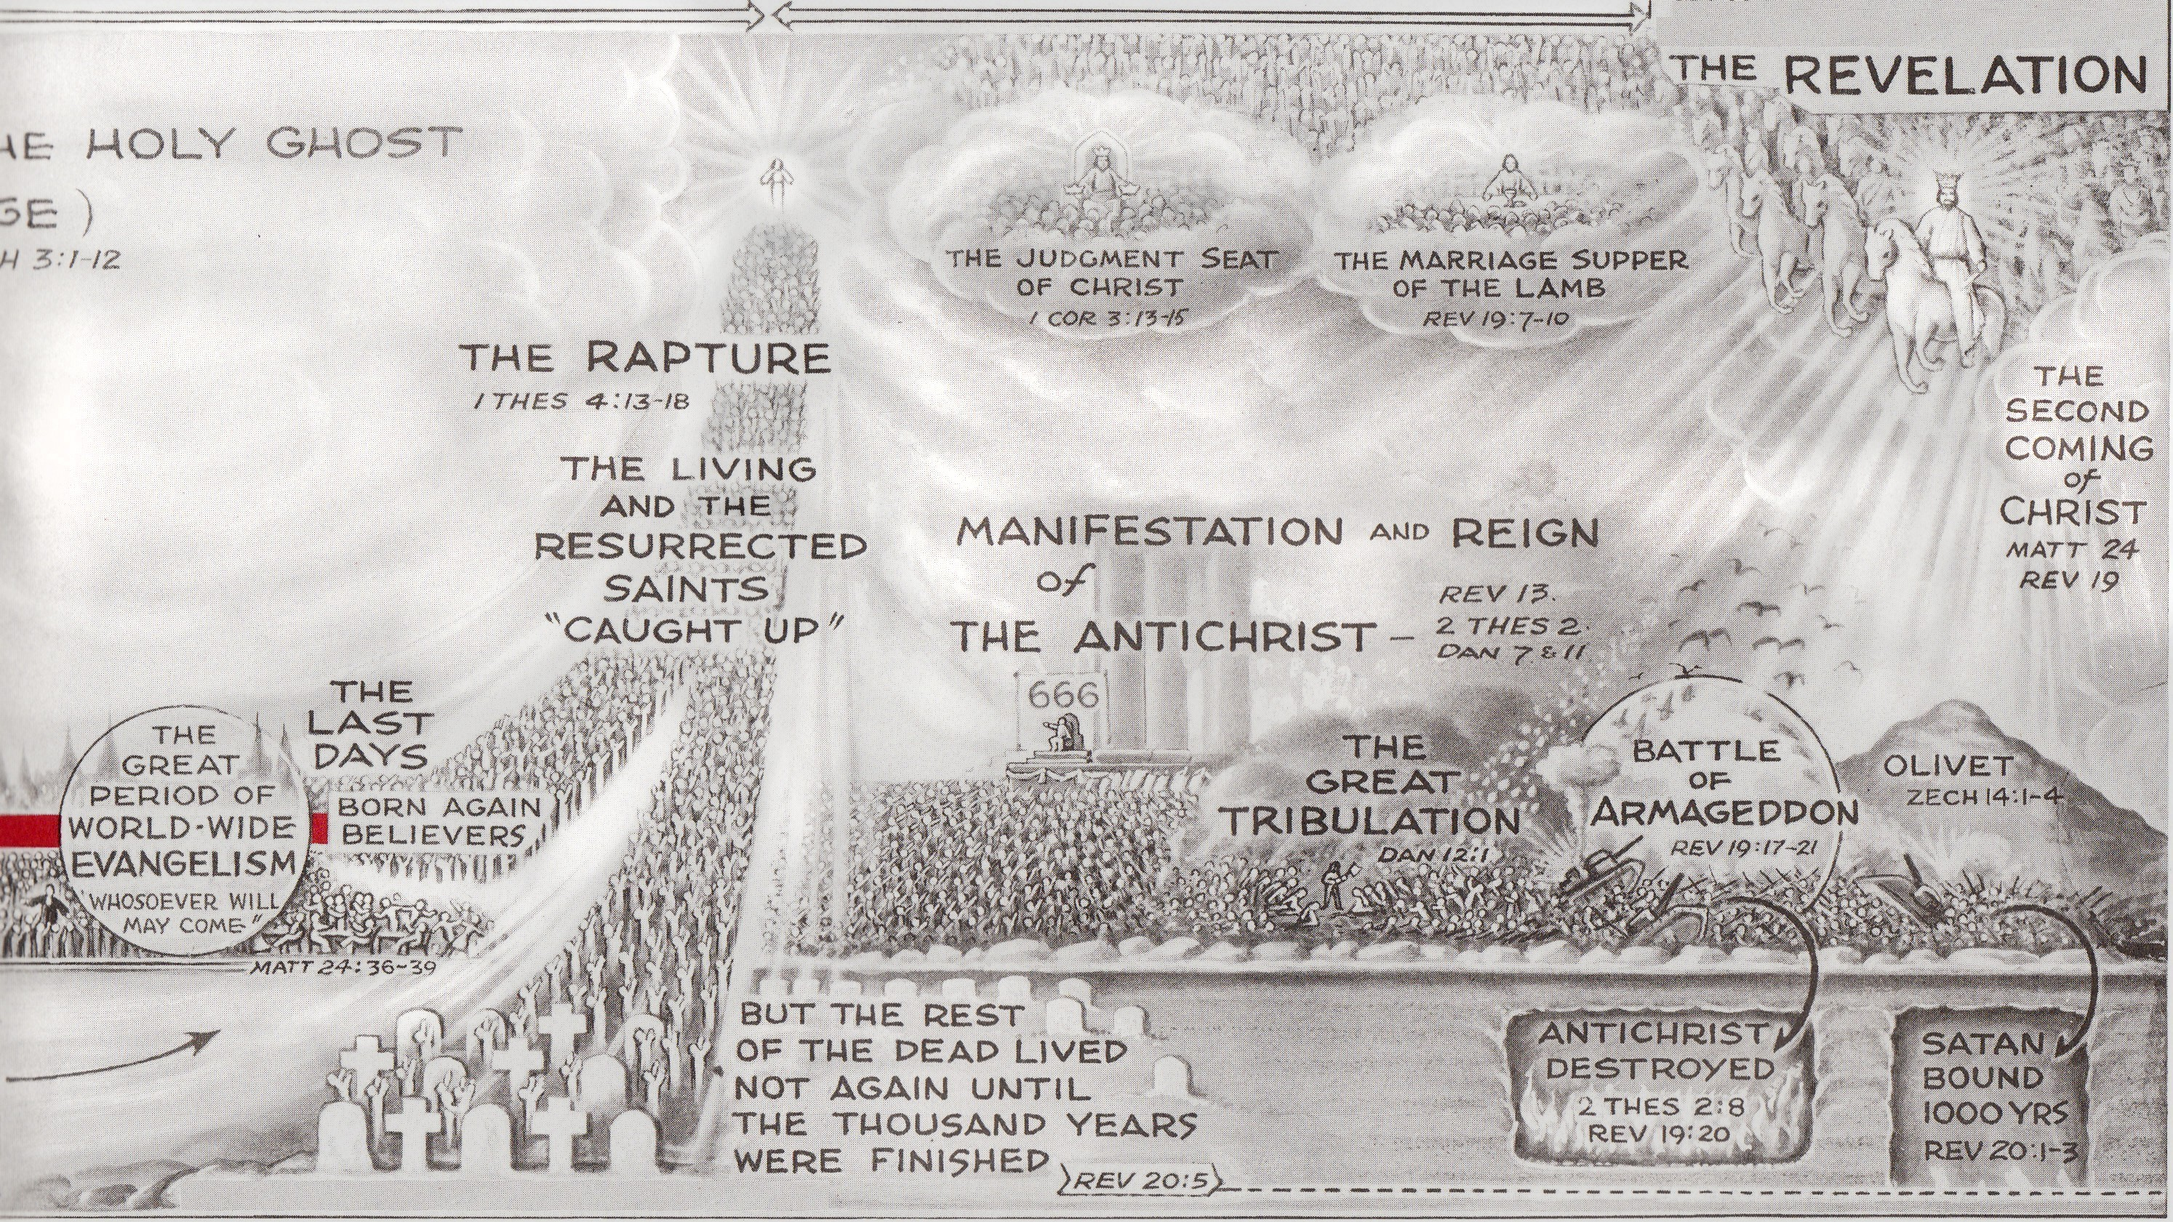

[ see publication source and order web site on last page ]

**I Thessalonians Chapter 4 – The Case of the Dead in Christ**

The Occasion: Timothy’s Report: Uncertainty about the dead in Christ?

The reason for I Thessalonians is the need to answer a concern Paul was made aware of via Timothy about the place of the dead in Christ in the Resurrection. Timothy’s report isn’t shown in the epistle but this issue is inferred from the way Paul answers them –

*“that you be not grieved . . about those who are asleep”*

**Evaluating on the Basis of What Paul Taught**

**Scenario A – Paul Taught Second Coming Only – no Rapture**

(Keep in mind here what basic evangelism would have taught about the Resurrection)

If there is only one Coming and the resurrection it includes, and Paul taught the basics which had to include the hope of eternal life, why would Thessalonian believers express concern about the state of the Christian dead? Is it not clear that all have the hope of eternal life after death?

We would be forced to conclude:

1. Paul mis-taught them about the resurrection. (We’re against any such suggestion.)
2. The Thessalonians were sadly inattentive. (Likewise, it’s equally hard to believe that anyone could come away from Paul as a distracted, inattentive student and still be confirmed by him as a member of the believing church.)

Neither of these is reasonable, which causes us to doubt how Paul could have taught Second Coming only, and entertain a question like this from the Thessalonian church.

**Scenario B – Paul Taught a Rapture Distinct from the Second Coming**

**The misunderstanding must be about details**

* Did the Rapture apply only to those living?
* Are the dead in Christ to be delayed to the Second Coming?

If delayed, they would not be part of the Rapture occurring first, and they may not have had the details this early as to how long the interval between Rapture and Second Coming would be. Hence, concern and distress as to when they would be joined with their deceased loved ones.

**Conclusion:**

Paul taught the Rapture as distinct from the Second Coming, but these believers were unclear on the details.

I Thessalonians 5 – Not Appointed to Wrath

*9 “For God has not destined us for wrath, but for obtaining salvation,”*

Before leaving I Thessalonians for the second epistle, Paul offers an important doctrinal point that bears on the implication that there must be a Rapture before the Tribulation, separate from the Second Coming.

Just after the description of our being caught up with the Lord at His appearing (Ch 4), Paul describes the Day of the Lord as conditions of judgment and darkness that await the sons of darkness. This description would be logically out of place if the appearing was the Second Coming. The Day of the Lord would be at an end in terms of the persecution of antichrist and the wrath of God against the unrighteous.

In this section, Paul then says we are not appointed to wrath. Wrath would in fact be the characteristic of the Day of the Lord, when the earth and its inhabitants are subjected to judgments from God falling from Heaven. If we are not subject to wrath, then we cannot be present when the Day of the Lord unfolds.

Nor is it a case of having a Goshen at hand where all believers can congregate and be protected from what is happening. The effects are world-wide, affecting water supplies, agriculture, cities, infrastructure, etc. Christians of the Church living through that time would not be immune from the effects of these judgments, therefore would be subject to the wrath that is originating them.

The resolution is to conclude that Paul is offering this in keeping with a doctrine of the Rapture, whereby believers of the Church age will be taken out of the earth before it receives the effects of this wrath in the Day of the Lord.

In fact, the chief worry of the Thessalonian believers is that this Day of the Lord has for some inexplicable reason come upon them. Aside from the natural fears of the effects, believers would be equally dismayed at why they are being subjected to the wrath they represent.

II Thessalonians Chapter 2 – Has the Day of the Lord Come?

The Occasion: They have missed the Rapture and are entering the Day of the Lord

The subject of this letter was to comfort believers who were distressed in thinking the Day of the Lord was upon them and they had missed the catching up described in Paul’s first letter -

(I Thessalonians).

Some see the distress itself as proof they must have been taught the Rapture and would escape the Day of the Lord, thus a proof by necessary inference.

However, their distress can also be explained by their simple humanity in facing a now imminent suffering, even if one they had been taught all along to expect. This is witnessed in the events of the Roman persecutions, where most believers did not anticipate their suffering in a blissful freedom from distress.

Again, we gain some insight by evaluating Paul’s answer to them on the basis of which teaching he has given them:

**Evaluating on the Basis of What Paul Taught**

**Scenario A – Paul Taught Second Coming Only – No Rapture**

**Where is the comfort in Paul’s clarification?**

* You’re not in the Day of the Lord - *yet*
* No worries about imminent suffering
* But be prepared for it soon – here are the signs . .

Example: New legislation is coming and next year citizens can expect a 50% increase in taxes and the beginning of health care panels to permit or deny care.

A pastor seeks to comfort members:

*“I have good news. These things will not happen in 2013, so take comfort.”*

*“But they are planned for 2014.”*

**Scenario B – Paul Taught a Rapture Distinct from the Second Coming**

* There is reason for comfort and hope
* They have not missed the Rapture
* They will escape the effects of the day of vengeance

In this comparison, we must weigh how Paul’s reply comforts believers in a scenario where they will face the events of the Day of the Lord, even if he is telling them they are misinformed about its timing.

We would expect words that encourage their faithful endurance and courage, not merely a recitation of the evils that will take place when the real Day arrives.

The only scenario that provides genuine comfort to their condition is the declaration that they are not in the Day of the Lord (by reminding them of the signs that will signal it), *and that they have not lost their opportunity to escape it.*

**Conclusion:**

Paul taught the Rapture as distinct from the Second Coming. These believers have been misinformed about having missed it.

**Differences in the Descriptions of the Lord’s Coming**

**The Book of Revelation – a visible coming to the world:**

* All the earth is witness to His appearance
* It is a day of reward and a day of vengeance
* He descends downward bringing a host with Him
* antichrist is slain at His appearance
* He continues to the earth
* Those who meet Him remain on the earth
* He sets up judgment

**I Thessalonians Ch 4 – a silent coming to the world:**

* He comes only for the Church
* The rest of the earth is not mentioned as seeing His appearance
* It is not a day of vengeance
* He does not descend to the earth but remains in the air
* Believers go up to meet Him
* Only reward: eternal presence follows the event

We are inclined to conclude that the coming in I Thessalonians is strikingly different from the Second Coming, and may therefore be describing the coming we call the Rapture.

**Key Terms of Rapture Terminology**

**The Sign of Apostasy - *apostasia***

***“for it will not come unless the apostasy comes first,”*** (2 Thess 2:3)

We are slow to accept a suggestion that *apostasia* might not mean our normal word apostasy or falling from the faith, because the Greek word is so like our English word.

But the similarity goes in one direction only – from Greek toward popular English usage, not backwards from English usage so as to define the Greek.

As it happens, there actually are examples of *apostasia* being used to describe simple physical separation, as in a departure or removal (Luke 2:27, 2 Cor 12:8, Acts 12:10, Luke 4:13).

In fact, English translations prior to the King James Version consistently translated the above as, *“unless the departure comes first.”*

So it is not definitive that the word *apostasia* in 2 Thess 2:3 cannot refer to the Rapture. The fact that so many modern translations since the King James Version continue to use ‘apostasy’ may be explained by the notable lack of emphasis on end times topics in our recent past, which might have prompted reconsideration of the word.

Still, it remains a matter less of linguistics and scholarship and more a matter of the differences in conviction about what the sentences were meant to convey.

**Restrainer - Is the Restrainer the Church or the Holy Spirit?**

***“only he who now restrains will do so until he is taken out of the way.,”*** (2 Thess 2:8)

The thrust of this distinction is that if the restrainer can be seen as *the Church*, this bolsters the conclusion that we have an additional picture of the Rapture in 2 Thessalonians.

**Interpretation A - The Holy Spirit**

Others have suggested that the restrainer might be the Holy Spirit. The appeal to this is that the Holy Spirit is more omnipresent in the world and individual affairs of human beings and can restrain more effectively that the external physical presence of the Church.

The problem with the Holy Spirit as restrainer is that people will continue being saved after this removal, and salvation without the operation of the Spirit is difficult to explain.

**Interpretation B - The Church**

While it can be argued that the Church’s presence has been a restraining force against evil through human history, it is not clear that evil will be *unleashed* by the Church’s removal. This is in part due to our comprehension that evil has gone to such hideous lengths in the world so that the idea of it waiting to be unleashed has less and less meaning.

It seems that evil is advancing truly in spite of the Church’s presence and this weakens our understanding of its restraining power.

But in 2 Thessalonians, the removal of the restrainer is followed immediately by the revealing of the lawless one. So one might conclude that the restrainer has more to do with the rise of antichrist than the advance of evil.

Still, in the final analysis, there limited candidates for the restrainer, and the Holy Spirit is discounted more strongly for the reasons above, leaving the Church as the likely choice.

**Panorama View Bible Study Course No. 1, Oak Knoll Publishing (formerly Revell)**

